1 Introduction to Computer
Programming
1.1 Objectives

In this section, we will be discussing the basic components of a computer, both hardware and software. We will also be giving a brief overview of programming languages and the program development life cycle. Finally, different number systems and conversions from one type to another will be discussed.
At the end of the lesson, the student should be able to:
Identify the different components of a computer
Know about programming languages and their categories
Understand the program development life cycle and apply it in problem solving Learn the different number systems and their conversions

1.2 Introduction

A computer is a machine that performs a variety of tasks according to specific instructions. It is a data processing machine which accepts data via an input device and its processor manipulates the data according to a program.
The computer has two major components. The first one is the Hardware which is the tangible part of the computer. It is composed of electronic and mechanical parts.

The second major component is the software which is the intangible part of a computer. It consists of data and the computer programs.

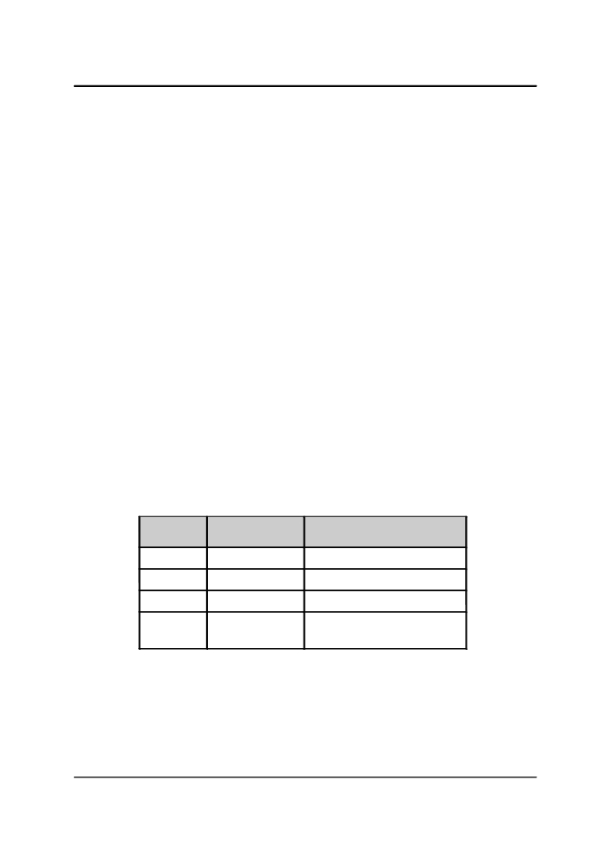

1.3 Basic Components of a Computer
1.3.1 Hardware

1.3.1.1 The Central Processing Unit
The processor is the “brain” of the computer. It contains millions of extremely tiny electrical parts. It does the fundamental computing within the system. Examples of processors are Pentium, Athlon and SPARC.

1.3.1.2 Memory
The memory is where data and instructions needed by the CPU to do its appointed tasks can be found. It is divided into several storage locations which have corresponding addresses. The CPU accesses the memory with the use of these addresses.

1. Main Memory
The main memory is very closely connected to the processor. It is used to hold programs and data, that the processor is actively working with. It is not used for long-term storage. It is sometimes called the RAM (Random Access Memory).
The computer's main memory is considered as volatile storage. This means that once the computer is turned off, all information residing in the main memory is erased.

2. The Secondary Memory
The secondary memory is connected to main memory. It is used to hold programs and data for long term use. Examples of secondary memory are hard disks and cd-rom.
Secondary memory is considered as non-volatile storage. This means that information residing in secondary memory is not erased after the computer is turned off.

Main Secondary
Memory Memory
Fast Slow
Expensive Cheap
Low High

Yes No

Property

Speed
Price
Capacity Volatile

Table 1: Comparison between main memory and secondary memory



1.3.1.3 Input and Output Devices
Input and output devices allows a computer system to interact with the outside world by moving data into and out of the system.
Examples of input devices are keyboards, mice and microphones. Examples of output devices are monitors, printers and speakers.

1.3.2 Software
A software is the program that a computer uses in order to function. It is kept on some hardware device like a hard disk, but it itself is intangible. The data that the computer uses can be anything that a program needs. Programs acts like instructions for the processor.

Some Types of Computer Programs:

1. Systems Programs
Programs that are needed to keep all the hardware and software systems running
together smoothly

Examples:
Operating Systems like Linux, Windows, Unix, Solaris, MacOS

2. Application Programs

Programs that people use to get their work done

Examples:
Word Processor
Game programs
Spreadsheets

3. Compilers
The computer understands only one language: machine language. Machine
language is in the form of ones and zeros. Since it is highly impractical for people
to create programs out of zeros and ones, there must be a way of translating or
converting a language which we understand into machine language, for this purpose, there exists compilers.

1.4 Overview of Computer Programming Languages
1.4.1 What is a Programming Language?

A programming language is a standardized communication technique for expressing instructions to a computer. Like human languages, each language has its own syntax and grammar.
Programming languages enable a programmer to precisely specify what data a computer will act upon, how these data will be stored/transmitted, and precisely what actions to take under various circumstances.
There are different types of programming languages that can be used to create programs, but regardless of what language you use, these instructions are translated into machine language that can be understood by computers.

1.4.2 Categories of Programming Languages

1. High-level Programming Languages
A high-level programming language is a programming language that is more user
friendly, to some extent platform-independent, and abstract from low-level
computer processor operations such as memory accesses. A programming
statement may be translated into one or several machine instructions by a compiler.

Examples are Java, C, C++, Basic, Fortran

2. Low-level Assembly Language
Assembly languages are similar to machine languages, but they are much easier to
program in because they allow a programmer to substitute names for numbers.
Assembly languages are available for each CPU family, and each assembly
instruction is translated into one machine instruction by an assembler program.
Note: The terms "high-level" and "low-level" are inherently relative. Originally, assembly language was considered low-level and COBOL, C, etc. were considered high-level. Many programmers today might refer to these latter languages as low-level.

Introduction to Programming I

1.5 The Program Development Life Cycle

Programmers do not sit down and start writing code right away when trying to make a computer program. Instead, they follow an organized plan or methodology, that breaks the process into a series of tasks.

Here are the basic steps in trying to solve a problem on the computer:

1.Problem Definition
2.Problem Analysis
3.Algorithm design and representation (Pseudocode or flowchart)
4.Coding and debugging
In order to understand the basic steps in solving a problem on a computer, let us define a single problem that we will solve step-by-step as we discuss the problem solving methodologies in detail. The problem we will solve will be defined in the next section.

1.5.1 Problem Definition

A programmer is usually given a task in the form of a problem. Before a program can be designed to solve a particular problem, the problem must be well and clearly defined first in terms of its input and output requirements.
A clearly defined problem is already half the solution. Computer programming requires us to define the problem first before we even try to create a solution.

Let us now define our example problem:

“Create a program that will determine the number of times a name occurs in a list.”

1.5.2 Problem Analysis

After the problem has been adequately defined, the simplest and yet the most efficient and effective approach to solve the problem must be formulated.
Usually, this step involves breaking up the problem into smaller and simpler subproblems.

Example Problem:
Determine the number of times a name occurs in a list

Input to the program:
list of names, name to look for

Output of the program:
the number of times the name occurs in a list

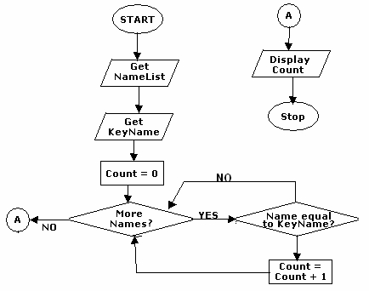

1.5.3 Algorithm design and representation

Once our problem is clearly defined, we can now set to finding a solution. In computer programming, it is normally required to express our solution in a step-by-step manner.
An Algorithm is a clear and unambiguous specification of the steps needed to solve a problem. It may be expressed in either Human language (English, Tagalog), through a graphical representation like a flowchart or through a pseudocode, which is a cross between human language and a programming language.
Now given the problem defined in the previous sections, how do we express our general solution in such a way that it is simple yet understandable?

Expressing our solution through Human language:
1.Get the list of names
2.Get the name to look for, let's call this the keyname
3.Compare the keyname to each of the names in the list
4.If the keyname is the same with a name in the list, add 1 to the count
5.If all the names have been compared, output the result

Expressing our solution through a flowchart:

YES

Figure 1.1: Example of a flow chart

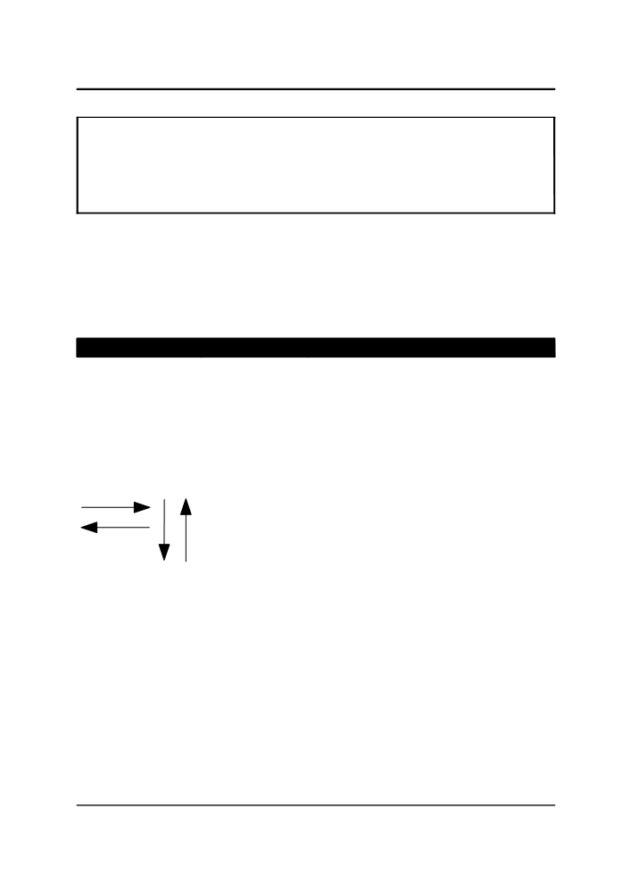
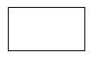
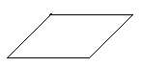
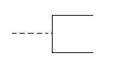
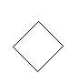
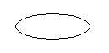

Expressing our solution through pseudocode:
Let nameList = List of Names
Let keyName = the name to be sought
Let Count = 0
For each name in NameList do the following
if name == keyName
Count = Count + 1
Display Count

Figure 1.2: Example of a pseudocode

1.5.3.1 Flowcharting Symbols and their meanings
A flowchart is a design tool used to graphically represent the logic in a solution. Flowcharts typically do not display programming language commands. Rather, they state the concept in English or mathematical notation.
Here are some guidelines for commonly used symbols in creating flowcharts. You can use any symbols in creating your flowcharts, as long as you are consistent in using them.

Symbol Name

Process Symbol

Input/Output
(I/O) Symbol

Flowline Symbol

Annotation
Symbol

Decision Symbol

Terminal Symbol

Meaning
Represents the process of executing a defined
operation or groups of operations that results in a change in value, form, or location of information. Also functions as the default symbol when no
other symbol is available.

Represents an I/O function, which makes data available for processing (input) or displaying
(output)of processed information.

Represents the sequence of available information
and executable operations.The lines connect
other symbols, and the arrowheads are
mandatory only for right-to-left and bottom-to
top flow.
Represents the addition of descriptive
information, comments, or explanatory notes as
clarification. The vertical line and the broken line
may be placed on the left, as shown, or on the
right.

Represents a decision that determines which of a number of alternative paths is to be followed.

Represents the beginning, the end, or a point of interruption or delay in a program.



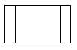

J.E.D.I

Symbol Name

Connector
Symbol

Predefined
Process Symbol

Meaning
Represents any entry from, or exit to, another part of the flowchart. Also serves as an off-page connector.

Represents a named process consisting of one or more operations or program steps that are
specified elsewhere.

Table 2: Flowchart Symbols
1.5.4 Coding and Debugging

After constructing the algorithm, it is now possible to create the source code. Using the algorithm as basis, the source code can now be written using the chosen programming language.
Most of the time, after the programmer has written the program, the program isn't 100% working right away. The programmer has to add some fixes to the program in case of errors (also called bugs) that occurs in the program. This process of is called debugging.
There are two types of errors that a programmer will encounter along the way. The first one is compile-time error, and the other is runtime error.
Compile-Time Errors occur if there is a syntax error in the code. The compiler will detect the error and the program won't even compile. At this point, the programmer is unable to form an executable that a user can run until the error is fixed.
Forgetting a semi-colon at the end of a statement or misspelling a certain command, for example, is a compile-time error. It's something the compiler can detect as an error.
Compilers aren't perfect and so can't catch all errors at compile time. This is especially true for logic errors such as infinite loops. This type of error is called runtime error.
For example, the actual syntax of the code looks okay. But when you follow the code's logic, the same piece of code keeps executing over and over again infinitely so that it loops. In such a case, compilers aren't really smart enough to catch all of these types of errors at compile-time, and therefore, the program compiles fine into an executable file. However, and unfortunately, when the end-user runs the program, the program (or even their whole computer) freezes up due to an infinite loop. Other types of run-time errors are when an incorrect value is computed, the wrong thing happens, etc.

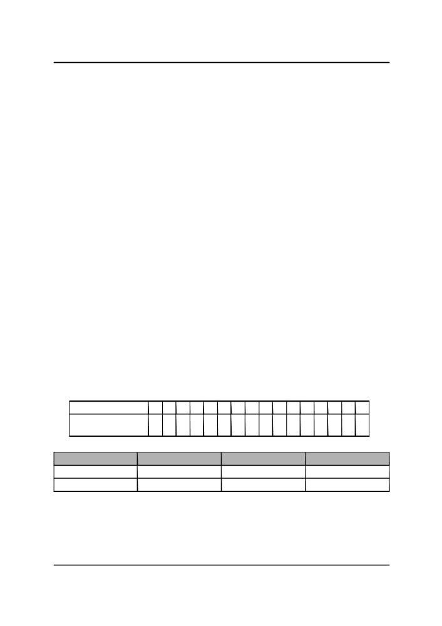

1.6 Number Systems and Conversions
Numbers can be represented in a variety of ways. The representation depends on what is called the BASE. The following are the four most common representations.
1.6.1 Decimal
We normally represent numbers in their decimal form. Numbers in decimal form are in base 10. This means that the only digits that appear are 0-9. Here are examples of numbers written in decimal form:
12610 (normally written as just 126)
1110 (normally written as just 11)
1.6.2 Binary
Numbers in binary form are in base 2. This means that the only legal digits are 0 and 1. We need to write the subscript 2 to indicate that the number is a binary number. Here are examples of numbers written in binary form:
11111102
10112
1.6.3 Octal
Numbers in octal form are in base 8. This means that the only legal digits are 0-7. We need to write the subscript 8 to indicate that the number is an octal number. Here are examples of numbers written in octal form:
1768
138
1.6.4 Hexadecimal
Numbers in hexadecimal form are in base 16. This means that the only legal digits are 09 and the letters A-F (or a-f, lowercase or uppercase does not matter). We need to write
the subscript 16 to indicate that the number is a hexadecimal number. Here are
examples of numbers written in hexadecimal form:
7E16
B16

Hexadecimal 0 1 2 3 4 5 6 7 8 9 A B C D E F
Decimal Equivalent 1
0 1 2 3 4 5 6 7 8 9 1011121314 5

Table 3: Hexadecimal Numbers and their Equivalence to decimal numbers
Decimal Binary Octal Hexadecimal
12610 11111102 1768 7E16
1110 10112 138 B16
Table 4: Summary of Examples

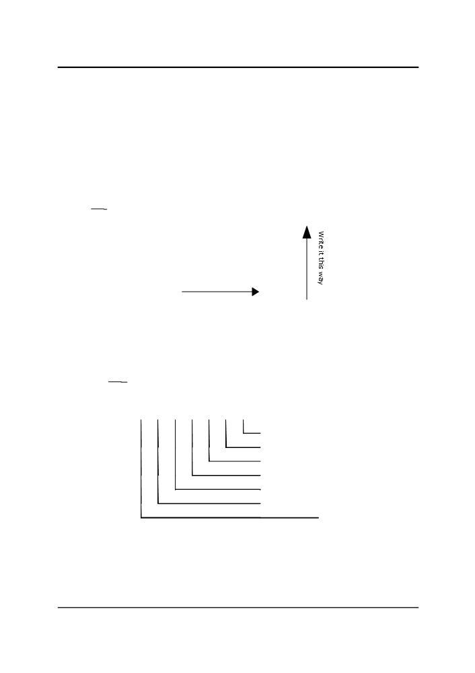

1.6.5 Conversions

1.6.5.1 Decimal to Binary / Binary to Decimal
To convert a decimal number to binary, continuously divide the number by 2 and get the remainder (which is either 0 or 1), and get that number as a digit of the binary form of the number. Get the quotient and divide that number again by 2 and repeat the whole process until the quotient reaches 0 or 1. We then get all the remainders starting from the last remainder, and the result is the binary form of the number.
NOTE: For the last digit which is already less than the divisor (which is 2) just copy the value to the remainder portion.

For Example:
12610 = ? 2

Quotient Remainder
126 / 2 = 63 0
63 / 2 = 31 1
31 / 2 = 15 1
15 / 2 = 7 1
7 / 2 = 3 1
3 / 2 = 1 1
1 / 2 = 1

So, writing the remainders from the bottom up, we get the binary number 11111102
To convert a binary number to decimal, we multiply the binary digit to "2 raised to the position of the binary number". We then add all the products to get the resulting decimal number.
For Example:
11111102 = ? 10

Position
Binary
Digits

6 5 4 3 2 1 0
1 1 1 1 1 1 0

0 x 20 = 0
1 x 21 = 2
1 x 22 = 4
1 x 23= 8
1 x 24= 16
1 x 25 = 32
1 x 26 = 64
TOTAL: 126

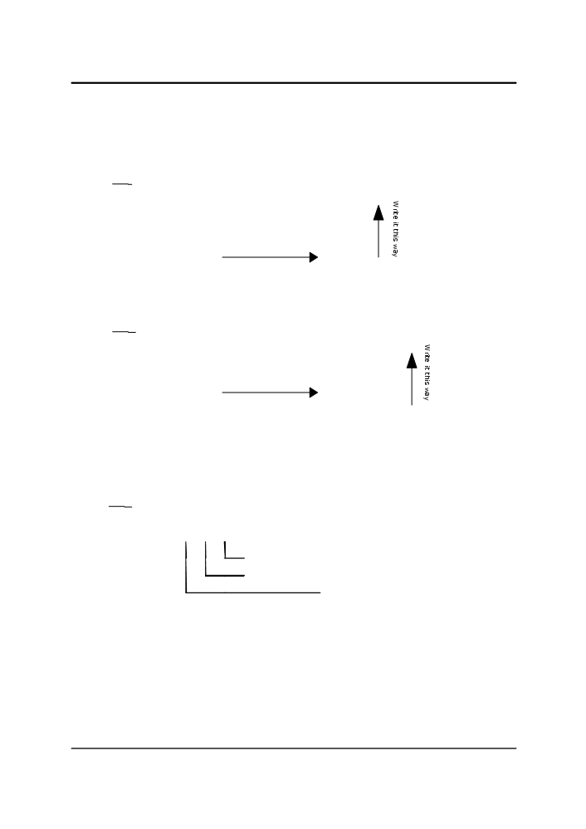

1.6.5.2 Decimal to Octal (or Hexadecimal)/Octal (or Hexadecimal) to Decimal
Converting decimal numbers to Octal or hexadecimal is basically the same as converting decimal to binary. However, instead of having 2 as the divisor, you replace it with 8(for octal) or 16 (for hexadecimal).

For Example (Octal):
12610 = ? 8

Quotient Remainder

126 / 8 = 15 6
15 / 8 = 1 7
1 / 8 = 1

So, writing the remainders from the bottom up, we get the octal number 1768

For Example (Hexadecimal):
12610 = ? 16

Quotient

126 / 16 = 7
7 / 16 =

Remainder
14 (equal to hex
digit E)
7

So, writing the remainders from the bottom up, we get the hexadecimal number 7E16
Converting octal or hexadecimal numbers is also the same as converting binary numbers to decimal. To do that, we will just replace the base number 2 with 8 for Octal and 16 for hexadecimal.
For Example (Octal):
1768 = ? 10

Position 2 1 0
Octal Digits 1 7 6
6 x 80 = 6 7 x 81 = 56 1 x 82 = 64 TOTAL: 126

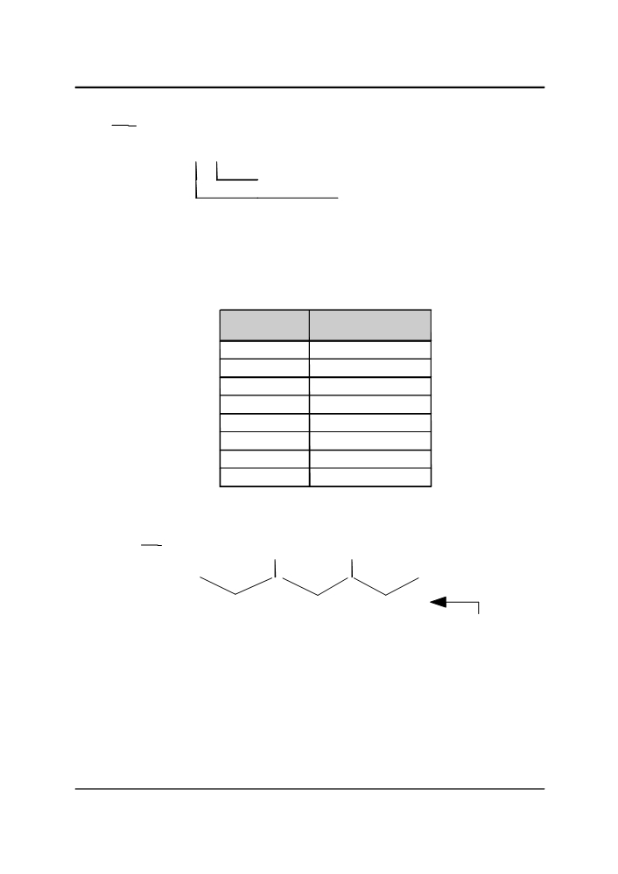

For Example (Hexadecimal):
7E16 = ? 10

Position 1 0
Hex Digits 7 E
14 x 160 = 14 7 x 161 = 112 TOTAL: 126

1.6.5.3 Binary to Octal / Octal to Binary
To convert from binary numbers to octal, we partition the binary number into groups of 3 digits (from right to left), and pad it with zeros if the number of digits is not divisible by
3. We then convert each partition into its corresponding octal digit. The following is a table showing the binary representation of each octal digit.

Octal Digit Binary
Representation
0 000
1 001
2 010
3 011
4 100
5 101
6 110
7 111

Table 5: Octal Digits and their corresponding binary represenation

For Example:
11111102 = ? 8

0 0 1 1 1 1 1 1 0

1 7 6
Equivalent octal number

Converting octal numbers to binary is just the opposite of what is given above. Simply convert each octal digit into its binary representation (given the table) and concatenate them. The result is the binary representation.

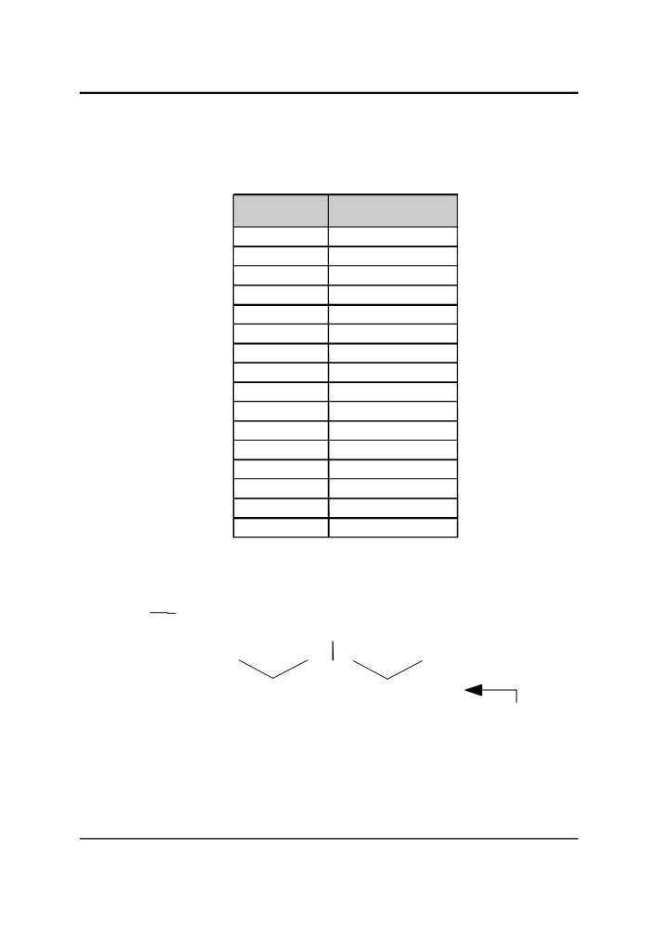

1.6.5.4 Binary to Hexadecimal / Hexadecimal to Binary
To convert from binary numbers to hexadecimal, we partition the binary number into groups of 4 digits (from right to left), and pad it with zeros if the number of digits is not divisible by 4. We then convert each partition into its corresponding hexadecimal digit. The following is a table showing the binary representation of each hexadecimal digit.

Hexadecimal Binary
Digit Representation
0 0000
1 0001
2 0010
3 0011
4 0100
5 0101
6 0110
7 0111
8 1000
9 1001
A 1010
B 1011
C 1100
D 1101
E 1110
F 1111

Table 6: Hexadecimal Digits and their corresponding binary represenation

For Example:
11111102 = ? 16

0 1 1 1 1 1 1 0

7 E
Equivalent Hexadecimal
number
Converting hexadecimal numbers to binary is just the opposite of what is given above. Simply convert each hexadecimal digit into its binary representation (given the table) and concatenate them. The result is the binary representation.

1.7 Exercises
1.7.1 Writing Algorithms
Given the following set of tasks, create an algorithm to accomplish the following tasks. You may write your algorithms using pseudocodes or you can use flowcharts.
1.Baking Bread
2.Logging into your laboratory's computer
3.Getting the average of three numbers

1.7.2 Number Conversions
Convert the following numbers:
1.198010 to binary, hexadecimal and octal
2.10010011012 to decimal, hexadecimal and octal
3.768 to binary, hexadecimal and decimal
4.43F16 to binary, decimal and octal

